12.02
Invoice Checking
Process Design & AMOS Configuration Document
Purpose
This Process Design document is provided to Key-Users to record their key decisions regarding the AMOS Process design and the required AMOS configuration.
It is updated throughout the Project Definition Phase and used as the baseline for the Final Acceptance prior to Go-Live
Revision
Author, Name | Date | Notes
Doncho Ivanov | 01.06.2024 | First Version

Table of Contents
1. Process Overview & Objectives 3
2. Regulatory References 3
3. Definitions & Glossary 3
4. Process Tasks 3
5. Process Dependencies 4
6. Process Flow 5
7. Process Design Questions 7
8. Data Source Mapping 11
9. Other Software Used 11
10. AMOS Configuration 12
a. Process specific configuration programmes 12
b. Basic Data 12
c. Parameters 13
d. Workflows 15
e. Scheduled Tasks 16
f. API’s & Interfaces 17
11. UAT Guidance 18
12. Annex – Additional Info 18

Process Overview & Objectives
Process General Description:
This process describes a flow of tasks to enable for 3-way matching of supplier invoices, as well as credit note and debit note processing. This process is usually executed by the Accounts Payable department of the organisation or alternatively by the Procurement department of the Technical division of the organisation, always complying with the 4-eyes principle. This process is continuously performed as it is an integral part of the overall procure-to-pay (P2P) process.
Main Process Objective (Outputs & Outcomes):
The main objective of this business process is to record the receipt of supplier invoices, validate them and match invoice items/details/lines with order items and goods receivings (or services booked) – complying with the 3-way matching principle – and close them in order to make them ready for export by means of automated interface to the Finance ERP system for the purpose of invoice posting and invoice payment.
In addition, the validation, matching and closing of credit notes, received from supplier, as well as the issue of debit notes to supplier, are also covered by this business process.
The execution of this business process also ensures correct valuation of the inventory stock, the fixed assets, and the final expenses.

Regulatory References
- Basic accounting principles
- IAS
- IFRS
- GAAP

Definitions & Glossary
Key-Words | Explanation
Creditor Account | It represents the supplier registration code (account) from the Finance ERP system
Debit note | Document, issued by the buyer and send to the supplier, to inform about adjustments made on the order, e.g. when goods received are being returned.
IAS | International accounting standards
IFRS | International financial reporting standards
GAAP | Generally accepted accounting principles

Process Tasks
Business Process Task / Actions / Activities:
- Update foreign currency exchange rates: Can be done manually or by means of automated interface at desired frequency.
- Generate new supplier: Supplier master system may be either AMOS or the Finance ERP system. In either case, if desired, relevant information may be exchanged between the systems by means of automated interfaces. However, it is a must to store in AMOS the supplier’s Creditor Account number.
- Process supplier invoice: Includes the registration (either manual, or by means of automated import interface), validation, matching and closing of supplier invoices, complying with the 3-way matching principle. The closed invoices are ready for export to the Finance ERP system for the purpose of posting and payment.
- Process proforma invoice and payments in advance: Primarily performed in the Finance ERP system. However, this task is also important to the AMOS business process when it comes to processing the final real invoice.
- Process supplier credit note: Includes the registration (either manual, or by means of automated import interface), validation, matching and closing of supplier credit notes, complying with the 3-way matching principle. The closed credit notes are ready for export to the Finance ERP system for the purpose of posting and payment. Only credit notes, exclusively related to supplier invoices that have already been closed in AMOS, are allowed to be processed.
- Issue debit note to supplier: Includes the generation of debit note to supplier in reference to already closed supplier invoice, to inform about adjustments made on the order, e.g. when goods received are being returned.
- Approve supplier invoice / credit note / debit note (according to Delegation of Authority / Limits of authority): Includes the official authorisation to close supplier invoice / credit note / debit note as per set of predefined rules, complying with the approval limits set in the organisation.
- Perform month-end reconciliation, validation and closing: Comprises of standard accounting practices, usually performed at the month-end, such as GR/IR account reconciliation, accrual accounting etc.

Process Dependencies
INPUT | CONCURRENT | OUTPUT
- 12.07 – Financial Multi-Entity: Intercompany transaction is initialised. | - 10.02 – Goods Receiving & Inspection: Required to perform 3-way matching.  - 12.02a – Invoice Checking: Required to process a credit/debit note as per 12.02b | - 12.01 – Financial Accounting: Generated accounting postings.  - 12.03 – Fixed Assets & Depreciation: Fixed asset acquisition cost adjustment (as required).  - 12.04 – Commercial Pricing & Billing: 3rd party supplier invoices available to recharge to customers.  - 12.06 – Budgeting & Cost Controlling: Generated relevant cost bookings.  - 12.07 – Financial Multi-Entity: Intercompany transaction is closed.

Process Flow

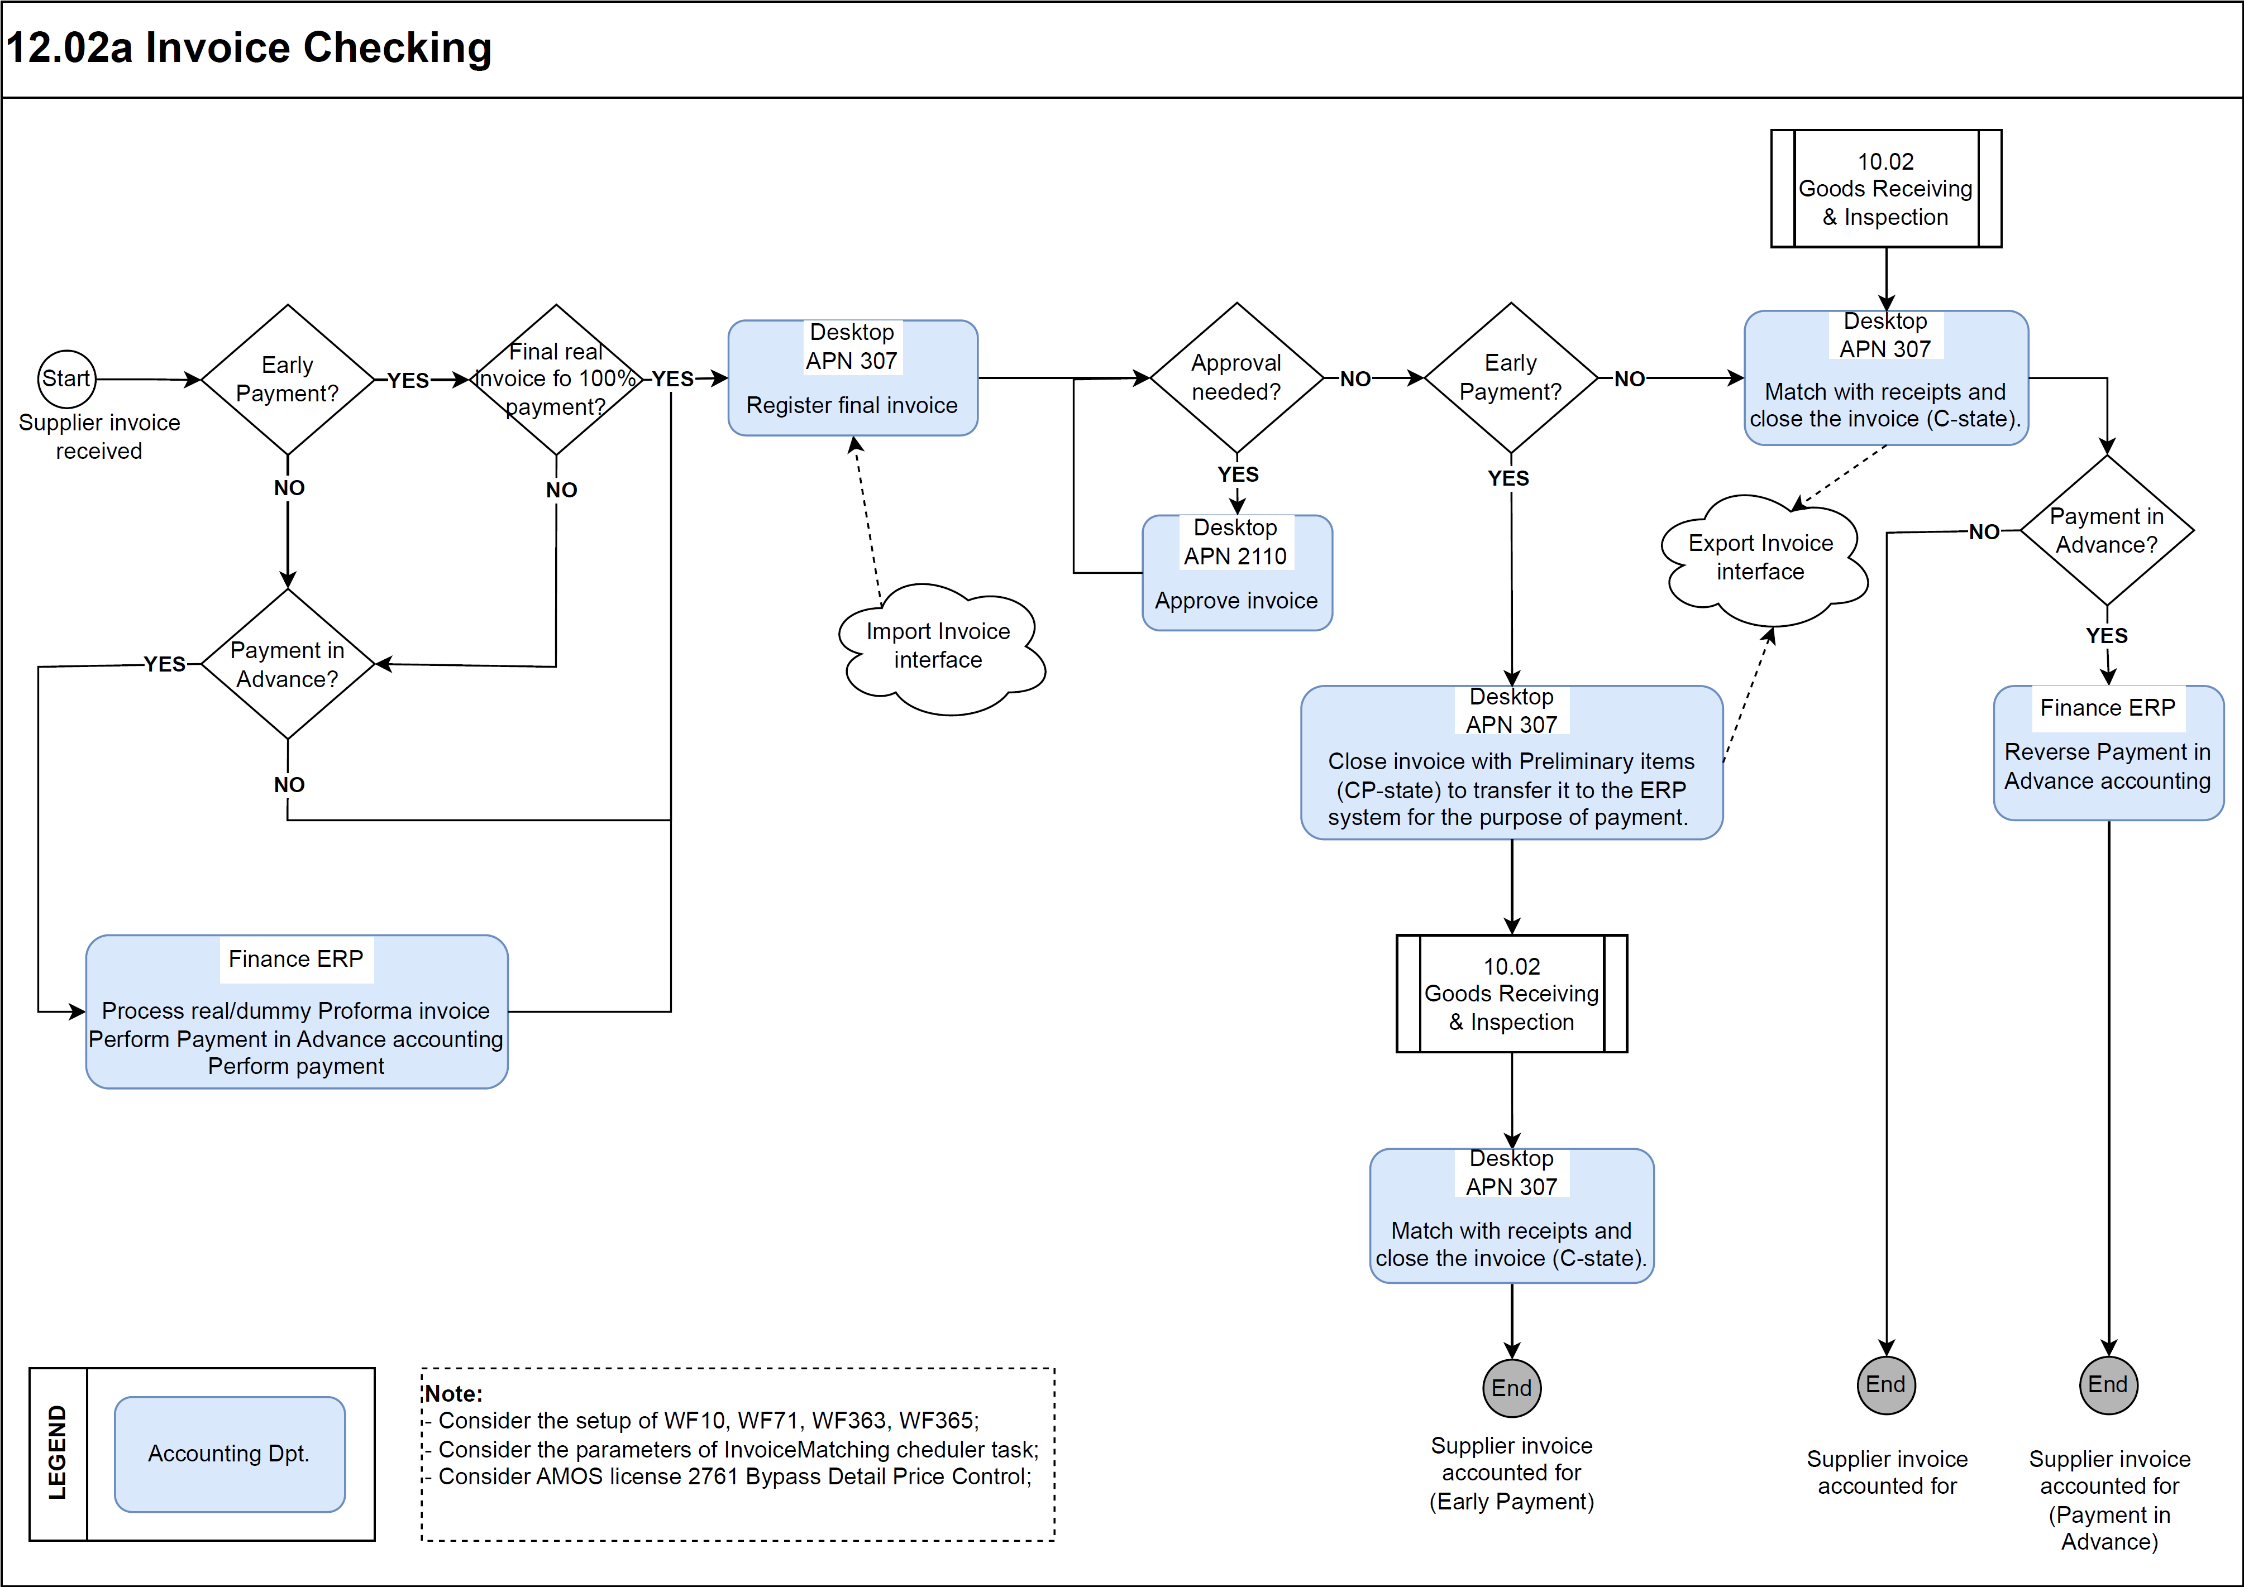
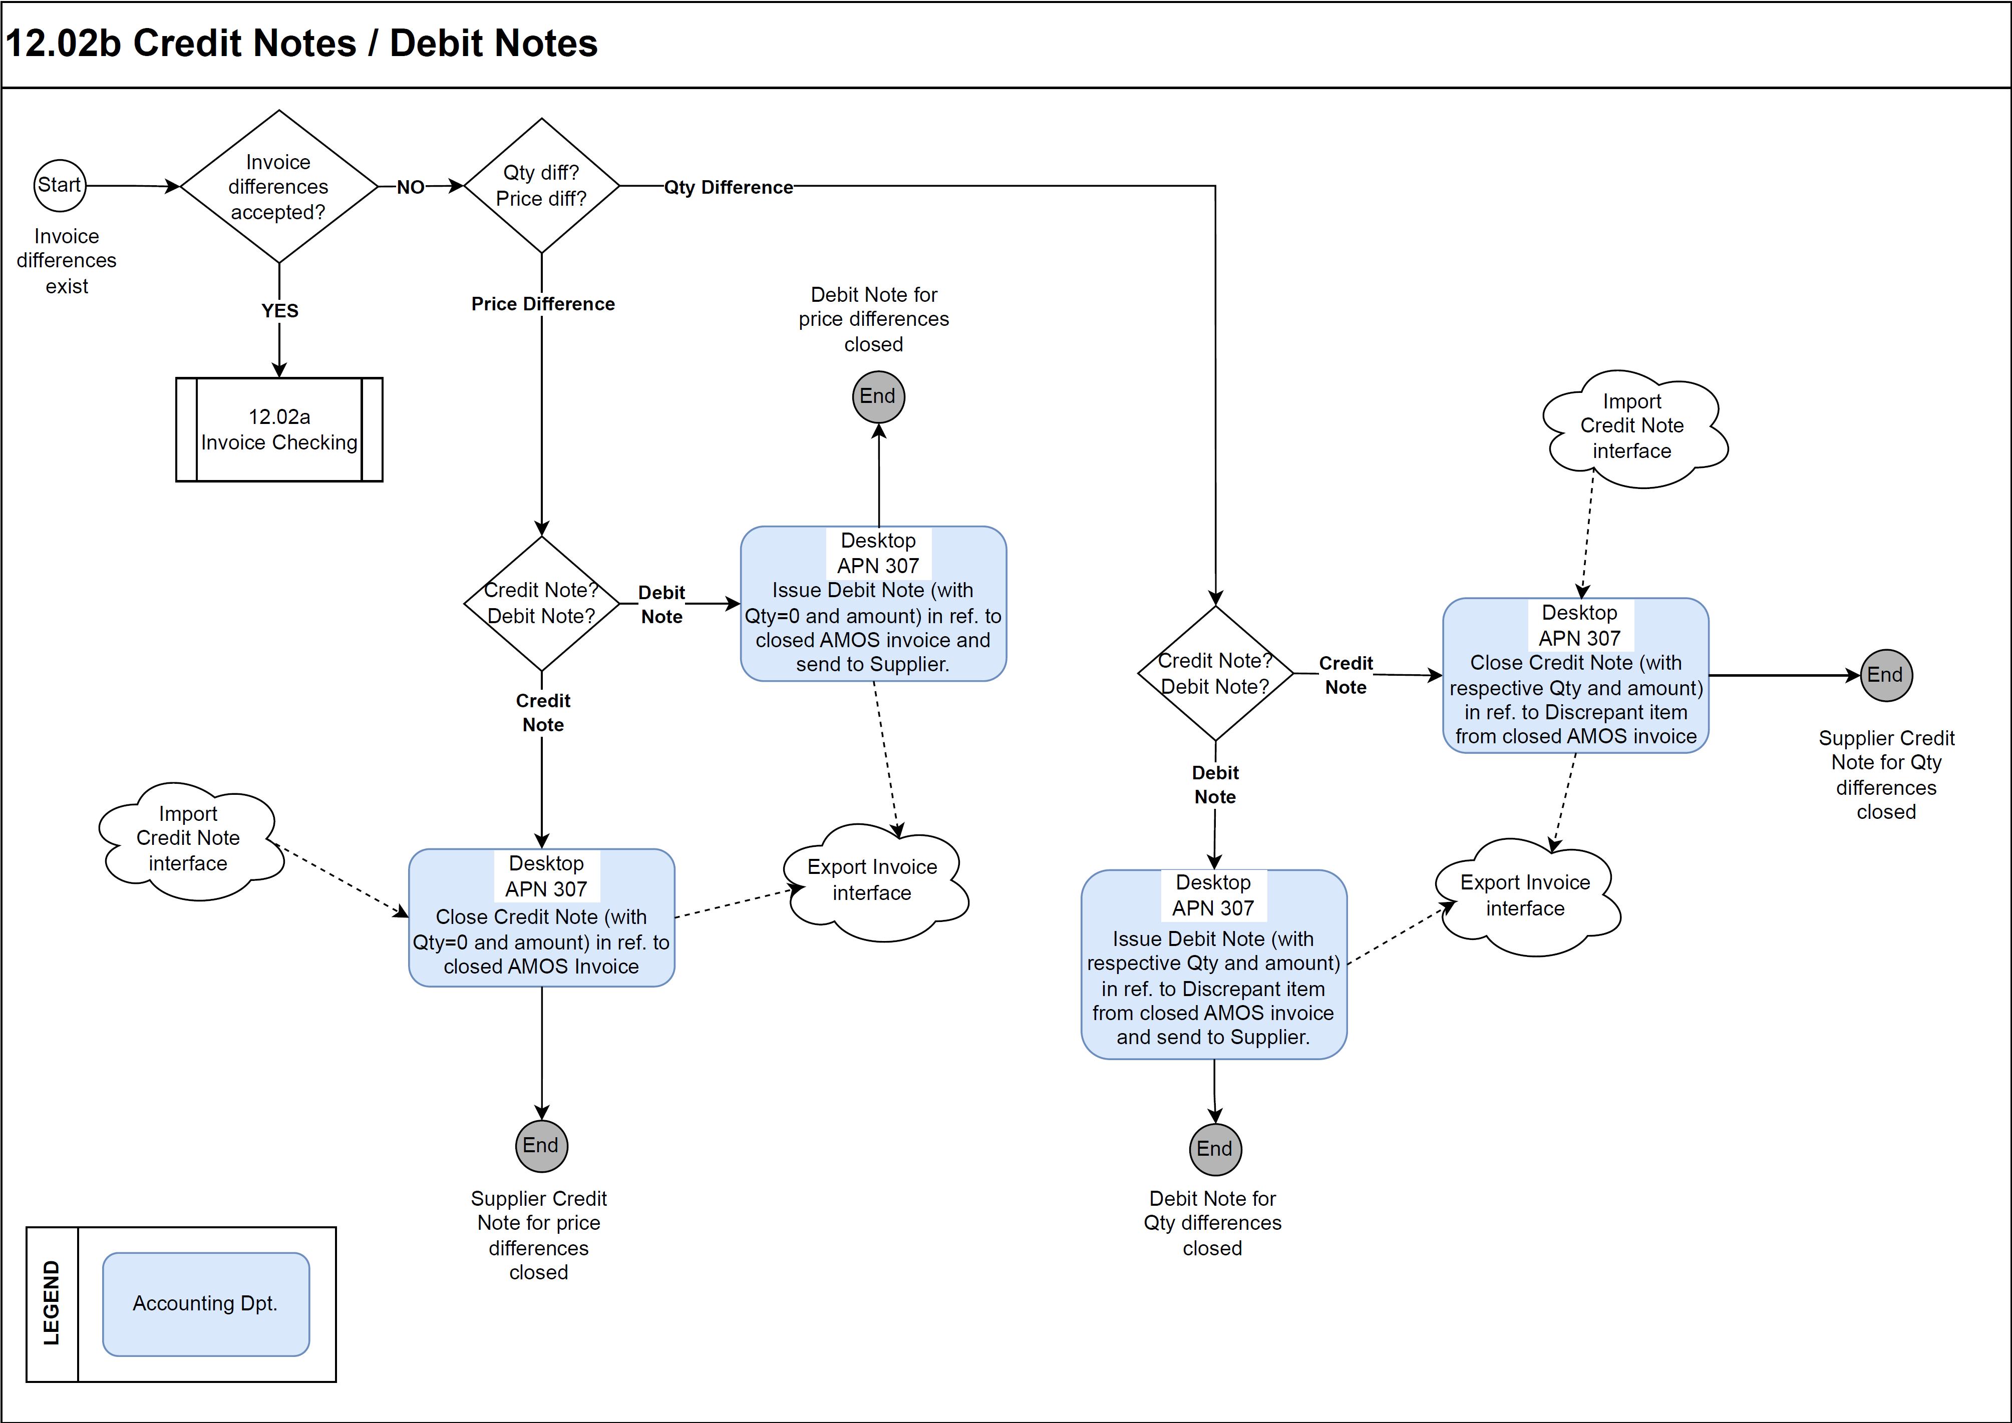

Process Design Questions
# | Question | Answer
1 | What is your company's accounting currency?
2 | How many foreign currencies are used in the Entity?
3 | How will foreign currency rates be entered into AMOS? (Manually or via interface)
4 | What will the frequency of the foreign currency rate updates be?
5 | In Multi-entity context, will the same foreign currency rate table be used by all entities?
6 | How will the process be for creating new suppliers in AMOS - opening Addresses (APN 53)? Should new supplier codes be first created in AMOS and then created in the financial system or the other way around?
7 | How are Invoices received at your company?
 | - Are they sent to a 3rd Party Company to be scanned?
 | - Are Physical Invoices sent to the Accounting A/P Dept.?
 | - Are Electronic Invoices received? From all Vendors or only from specific Vendors?
 | - Is there any interface for IATA invoices with your financial system?
 | - Is there any interface for Spec2000 invoices (Chapter 4, Customer Invoicing) with your financial or legacy system?
 | - Is there any interface for AeroRepair invoices?
8 | Which department/personnel will be responsible for recording the invoices in AMOS? Is it the same department/personnel responsible for the Invoice Checking?
9 | Are the Invoice documents received with a file containing the scanned Invoice Document image?
10 | How many invoices per month are processed?
11 | What should be the leading system to create invoice numbers - AMOS or other (financial system)? See parameter 809. The answer to this question also depends on the way the invoice interface between the systems is set.
12 | What internal Invoice number will be used - AMOS generated Invoice number or externally generated Invoice number? (see/set Parameter 809). If there are several entities, how is the invoice reference number process done? A range of references are given to each entity? Or the reference is sequential no matter the entity?
13 | Will AMOS-created Preliminary items be exported to the ERP-System (export of invoices in state Open)? If so, in which context?
14 | What posting are generated during the Invoice checking process?
15 | How is the accounting of invoice charges done - e.g. Bank charges; Freight etc.? Should they affect average price or not? Should they be inserted on the invoice header level or invoice details level?
16 | How do you manage currency differences between invoice document date, goods receiving date, invoice accounting date and invoice closing date?
17 | Are differences between invoice amount and invoice details allowed?  If yes, set parameter 878 and set up DC account on basic table (APN 18 - Charge type table). If you want to use the automatic invoice matching task, setup the conditions of differences allowed in AMOS Scheduler APN 2606. The parameter 878 is not applicable to automatic invoice matching task.
18 | Are differences between invoice and order allowed?  If not, please set up the workflow 71 Invoice Detail Control in APN:612 with the allowed tolerance, if applicable. If yes, but requires approval then setup an invoice approval process (parameter 1610 and APN 2111)
19 | What kind of payments in advance requests do you differentiate in your Organisation? e.g. payment in advance, cash in advance, down payment, partial payment, early payment, other?
20 | Do you perform payments in advance? How are they handled? What proportion (%) of invoices processed per month is related to payments in advance? How many invoices are these, roughly?
21 | How do you process and account for proforma invoices? What happens after the final invoice is received?
22 | Do you have payments in advance for 100% of the purchased goods value, but you are in possession of a final real supplier purchase invoice? (not proforma invoice). For instance, when you buy from a goods' supplier for the very first time?
23 | Does your Payment in advance accounting go through "Advance payment registration" account, incl. reversal of the same upon final invoice processing? For instance:
- Payment in advance registration:
Dr Advance Payments / Cr Accounts Payable (Creditor #)
- Payment processing in Financial ERP system:
Dr Accounts Payable (Creditor #) / Cr Bank
 | Or, does your Payment in advance accounting go through the supplier's creditor account directly? For instance:
- Payment in advance processing in Finance ERP system:
Dr Accounts Payable (Creditor #) / Cr Bank
 | without Advance payment registration?
24 | How are payments processed in the Finance ERP system - manually or automatically (considering the outstanding supplier credit balance)?
25 | What are credit notes usually received for (e.g. for price corrections, for volume discounts, for returned parts, for unreceived parts etc.)?
26 | How do you manage commercial and financial credits? AMOS only allows treating of commercial credits (quantity).
27 | Do you issue debit notes to suppliers (e.g. for returned parts)?
28 | How do you manage the month-end process of invoice checking? Should it be possible to change the invoice accounting date upon invoice registration in AMOS and introduce a date before the "today’s date"? Beware, if there is a difference between the invoice and order prices, the same will affect the financial stock value in AMOS as of the current month and generate GL bookings with "today’s date".
29 | How will the following scenario be managed: Vendor calls to know if the invoices will soon be paid?
30 | Which Financial ERP system do you need to integrate the data to? SAP; ORACLE, MS Dynamics, Navision, Axapta, Sage… other? Is there any middleware to be used? Do you use OCR (Object Caracter Recognition) system or any other Supplier invoice registration system or a Suppler portal?

Data Source Mapping
Data Sources | Description | Volume / Manual / Automatic / Static / Dynamic
-/- | -/- | -/-

Other Software Used
Other Software | Used by: | Description
-/- | -/- | -/-

AMOS Configuration

Process specific configuration programmes
AMOS APN | Notes
APN: 355 Currencies | Define the list of necessary foreign currency codes.
APN: 53 Address Administration – Currency tab | Define the supplier’s Creditor account information.
APN: 1664 Chart of Accounts | Define the necessary account numbers, used in the Invoice checking process.
APN: 3144 Cost Centre Assignment Rules | Define the rules for automatic assignment of cost centers.
APN: 1775 Part Financial Dashboard | Here part’s price may be changed manually.
APN: 2111 Approval Control Configuration | Configure the rules for approval of invoices / credit notes / debit notes, according to applicable Delegation of Authority / Limits of Authority policy of the organisation.
APN: 14 Admin Logins | Define the user logins and assign them to user roles.
APN: 15 Admin Roles | Define user roles and assign access rights (licenses) to each of them.
APN: 146 Staff Management | Define employee data. Link each employee to Financial entity.
APN: 1404 AIM Configuration | Configure required import/export interfaces. Scheduler task required to trigger the actual interface.
APN: 1470 AIM Webservice Configuration | Configure required import/export interfaces. No scheduler task required.

Basic Data
Basic Data Table | Notes
Charge Type | Define charge types, e.g. Handling, Freight, AOG charge
Invoice Accounting | Define rules to select a debit account to post on when an invoice is closed for received and matched items.
Invoice Accounting Discrepant Items | Define rules to select a debit account to post on when an invoice is closed for items marked as "Discrepant".
Invoice Document Type | Contains the valid codes of the different document types which an invoice may be classified with, if needed on export to the Finance ERP system.
Payment Mode | It is recommended to use the same codes as of the financial system.
Payment Condition | It is recommended to use the same codes as of the financial system.
Invoice Classification | User can define codes to mark invoices in Invoice Checking and classify them, e.g. dispute invoices which are not closed yet.

Parameters
Parameter Code | Parameter Name | Notes
814 | ROUNDING OF CURRENCY RATE | Defines the currency precision, e.g. setting Integer = 4 for 0.0000
842 | DEFAULT CURRENCY | Usually it is set with the local currency of the default entity, set in APN:1940.
843 | RATE TYPE FOR CURRENCIES | Defines the logic to be used (1.0 EUR = X.x USD, or X.x EUR = 1.0 USD). Usually, the 1.0 EUR = X.x USD logic is used. Set Integer = 2.
1726 | Financial Figures Rounding Mode | This Parameter controls the rounding method used by AMOS for the financial related figures.  It affects the currency conversion, the logistics modules (Order Management, Shipment, Goods Receiving), and billing and invoicing amounts rounding. By default, AMOS uses the Half Even method:  - When the next digit after the last “precision” digit is between 0 and 4, the number will be rounded down.  - When the next digit after the last “precision” digit is between 6 and 9, the number will be rounded up.  When the next digit after the last “precision” digit is 5, the number will be rounded to the closest even number.
809 | AUTOMATIC INVOICE NUMBER | This parameter shall be set depending on the process and the source system for invoices.
878 | DIFFERENCE ALLOWED IN INVOICE | This parameter controls the difference allowed in Invoice - between Invoice total amount and the sum of all Invoice details (only in original invoice currency). Note, that the minimum value which may be set up is 0.01.
1200 | ALLOW ENTRY OF ADDITIONAL CHARGES | NOT to be used by new AMOS customers.
1446 | Activate Tax Code Mode | Enables the definition of tax code on each invoice detail, instead of using the invoice header surcharges table.
1446 | Enable Tax Amount Edition | Enables the field to edit the system calculated tax amount.
1700 | Enable `On Hold` status for Transfer | By default, when the financial consistency is ensured in Amos via parameter 1471, an invoice whose order type affects the average price, always has to be selected by the invoice interface and its transfer can therefore not be set on hold (radio button Transfer Hold inactive).  The restriction is meant to prevent from stock value discrepancies between Amos and the financial system.  If the booking of the invoice has no direct impact on the stock account this parameter may be used in order to allow to temporarily put the transfer of the invoice on hold.
1733 | Enable Preliminary Closing | This parameter gives the possibility to enable the closing of invoices containing Preliminary Items. With the corresponding state CP, invoices of this type (e.g. early payment invoice) can be transferred to the financial system with the dedicated AIM interface to perform payment.
1855 | Consider invoice unit price lower than order unit price as a price discrepancy | This parameter determines whether an invoice unit price lower than the corresponding order unit price is considered as a price discrepancy or accepted.
873 | CONSIDER CURRENCY RATE AT CLOSING | Enables activation of a special function where the Invoice currency rate can be automatically updated to the new active currency rate when the Closing Date of the Invoice occurs in a period with a different active currency rate than when the Invoice was initially received.
1303 | ACTIVATE DAILY CURRENCY RATE MODE | For companies that update daily a different currency value (actual vs. budgeted). This enables a special function where the actual currency rate entered for the day of the Invoice Accounting date will be used instead of the currently active currency rate value.
1610 | Activate the Invoice Approval Control | Enables triggering the approval request upon closing of invoices/credit/debit notes upon closing as per company’s approval matrix, configured in APN: 2111 Approval Control Configuration.
907 | Detailed accounting is not required | This parameter must be set to ‘No’ when invoices are interfaced to Finance ERP system.
908 | Creditor account is not required | This parameter must be set to ‘No’ when invoices are interfaced to Finance ERP system.
1655 | Bypass stock account locking | This parameter must be set to ‘No’ when invoices are interfaced to Finance ERP system.
874 | ALLOW MANUAL ENTRY OF COST CENTER | Enables the manual input/update of a cost center on the invoice detail.
926 | Allow booking of an invoice without valid cost center | Defines whether the cost center field in Invoice Checking shall be mandatory.
1432 | Consider Free of charge invoices | This parameter gives the possibility to consider free of charge receivings in the calculation of the part’s average price.
1563 | CURRENCY RATE CHANGE IMPACT ON MOVING AVERAGE PRICE | Invoice price differences can also be caused by currency rate changes between goods receiving and invoice checking. When such a situation occurs, a DC booking (currency rate differences) will be generated. Then, if this parameter is set to NO, AMOS will not consider currency rate differences in average price calculation. Otherwise, if parameter is set to YES, currency rate differences will be considered in average price re-calculation. No DC-booking is written and currency rate differences are considered as normal price differences. Set up transaction IVD for the voucher mode ‘DC’ in Financial Transaction Definition (APN:1658).
1709 | Consider invoice bookings in consistency | This parameter enables increasing the scope coverage of the consistency analyser. It should be set to Y in order to include the general ledger bookings, generated during invoice checking, when analyzing financial consistency in order to ensure 100% completeness of analyzed financial bookings.
1595 | Use Entity Related Accounting | This parameter gives the possibility to customize the definition of the debtor / creditor financial data in APN: 53 Address Administration - Currencies tab.

Workflows
Workflow Number | Workflow Name | Workflow Setup Notes
10 | Notify Order Responsible | This workflow is triggered when the button next to the Order Responsible field is pressed in module Invoice Checking. Please note that this button only appears when the workflow is active.
71 | Invoice Detail Control | Used to control invoice vs order attributes, such as unit price, amount, currency. Note the wildcard ‘bypass_control’ in combination with license 2761 Bypass Detail Price Control.
190 | Invoice Deletion Control | This workflow is triggered when the invoice deletion process is started.  In combination with a Conditional Abort action, it can be used to limit the deletion of invoices by extending the default rules defined in the program.
223 | Moving Average Price Calculation | This workflow works in combination with parameter 1564 and may be used to notify the user when the newly calculated average price decreases/increases beyond a set tolerance limit.
313 | Invoice Deleted | This workflow may be used to notify Finance Dpt. that an AMOS invoice has been deleted, so appropriate actions shall be taken in the Finance ERP system.
365 | Invoice Header Control | This workflow may be used to inform the user that an invoice, having a dedicated payment condition, e.g. ‘EP’ – Early payment, may be closed in ‘CP’ – Closed preliminary state.
363 | Invoice Closing Control | This workflow may be used to prevent the user from closing an invoice in ‘CP’ – Closed preliminary state, when the invoice payment condition is not suitable, e.g. not ‘EP’ – early payment.
149 | AIM Export has completed | Setup workflow to monitor the errors of the interfaces.
97 | AIM Logging Notification | This workflow is triggered whenever ERROR_LOG or a WARNING_LOG is written by AIM. It may be used to send an e-mail with the log message.
249 | AIM Import has completed | This Workflow is executed after an AIM import. You can use it to be notified that the import is done. The message can contain a report of the import so you can see if any error or warning came up.
12 | Scheduler Task Message | This workflow will be triggered when a scheduler task is finished. With a rule you can access the output of Java Scheduler Tasks defined in AMOS Scheduler and inform users about the outcome.

Scheduled Tasks
Scheduled Task Reference | Frequency | Notes
Automatic Invoice Matching | 2*day | Enables automatic invoice matching process based on some rules and Preliminary items.
InitializeAddressEntityAccounting | once | Used only once whenever the Debtor/Creditor accounting per entity gets activated with parameter 1595 Use Entity Related Accounting.
Export Task | 2*day | Set up new scheduled Export Task to export the closed invoices via the interface configured in AIM Configuration (APN:1404).  If the customer decides to use Webservices (APN:1470), it is not necessary to set this task up.
AimFileImportService or FtpImportService or HttpImportService and IxosDocumentImportTask | 2*day | Used to import invoice header or invoice header & details via the interface configured in AIM Configuration (APN:1404).  If the customer decides to use Webservices (APN:1470), it is not necessary to set these tasks up.

API’s & Interfaces
Reference | Direction | Trigger | Frequency
EXPORT INVOICE | Export from AMOS | Invoices in status: Open / Closed / Closed Preliminary | 2*day
IMPORT INVOICE | Import to AMOS | Received e-Invoice (header or header + details). | 2*day
IMPORT CREDIT NOTES | Import to AMOS | Received credit and/or debit notes (header or header + details). | 2*day
IMPORT AEROREPAIR SERVICE ORDER INVOICE | Import to AMOS | Received e-Invoice from AeroRepair. | 2*day
IMPORT CURRENCY | Import to AMOS | Updated foreign currency rates. | as required
ATA_SparesInvoice | Import to AMOS | Received e-Invoice Header only via the Spec2000 Chapter 4 interface, Customer Invoicing, in accordance with the standard Spec2000 scheme ATA_SparesInvoice. | 2*day

UAT Guidance
Test case number | Test case description | Required data | Required resources
1 | Generate manually, validate, match and close a supplier invoice. No differences to order/receiving. | Received order | AP
2 | Generate manually, validate, match and close a supplier invoice. Unit price differences.  Note: invoice unit price > order unit price. | Received order | AP
3 | Generate manually, validate, match and close a supplier invoice. Qty differences (discrepant item).  Note: invoice Qty > received Qty. | Received order with less Qty than ordered | AP
4 | Generate manually, validate, match and close a supplier credit note. | Closed supplier invoice | AP
5 | Generate manually, validate, match and close a debit note to supplier. | Closed supplier invoice | AP
6 | Generate manually, validate and close preliminary a supplier invoice (Early payment process). | Open order | AP
7 | Import (header or header + details), validate, match and close a supplier invoice. | Received order | IT & AP
8 | Impot (header or header + details), validate, match and close a supplier credit note. | Closed supplier invoice | IT & AP
9 | Export closed invoice. | Closed invoice | IT & AP
10 | Export open invoice. | Open invoice | IT & AP
11 | Export invoice in state closed preliminary (Early payment process). | Invoice in state closed preliminary | IT & AP
12 | Export closed credit note. | Closed credit note | IT & AP
13 | Export closed debit note. | Closed debit note | IT & AP
14 | Import foreign currency exchange rates | List of updated foreign currency exchange rates to be uploaded to AMOS | IT & AP

Annex – Additional Info
-/-

